REPUBLIC OF SERBIA

Report on the implementation of recommendations no. 15, 33 and 39 from the Concluding Observations of the UN Human Rights Committee regarding the Third Periodic Report on the implementation of the
International Covenant on Civil and Political Rights

Roma inclusion
15.(a)

Forthcoming amendments to the Anti-Discrimination Law in the RSerbia will significantly improve the status of members of the Roma Community.

Education
The number of pedagogical assistants (a support measure that places the RSerbia among countries with good practices) will be increased from 175 (35 in pre-school institutions) by another 50.
Mentor support (201 mentors) was continued during the 2016/17 and 2017/18 school years.
A total of 150 student scholarships were awarded from the budget during the 2016/17 school year for female students with excellent grades in secondary school (60% girls), with another 303 scholarships approved during the 2017/18 school year. The Rulebook on amendments to the Rulebook on pupils’ and students’ loans and scholarships was adopted in early December 2017, establishing more lenient criteria for awarding scholarships and loans to members of vulnerable social groups. Thus, under certain circumstances, scholarships are also provided to students with very good grades (one grade below “excellent”). Scholarships are being continued through the new IPA 2014 project, funds have been secured from the budget of the Republic of Serbia for 300 secondary school students, and not only those with excellent grades. The Roma Education Fund approved 500 scholarships for the 2017/18 school year (secondary school students with average grades of 2.5 - 3.0). Secondary schools included 1,632 students during the 2016/17 school year, and 1,969 during the 2017/18 school year. One of the results of scholarships for secondary school students was a decrease in the drop-out rate - (from over 7% to 3%).
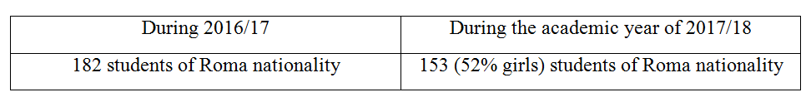
The Roma Education Fund provided scholarships through two programmes, for 72 regular students (RMUSP) and 26 students of medicine (RHP) with a mentor support programme and foreign language classes.
Data was collected during April 2017, in cooperation with the Standing Conference of Towns and Municipalities, from local self-government units where the coverage of children by the preparatory preschool programme and enrolment in first grade of primary school is below 90%. Thereafter, during May and June 2017, consultative workshops were held to expand coverage.

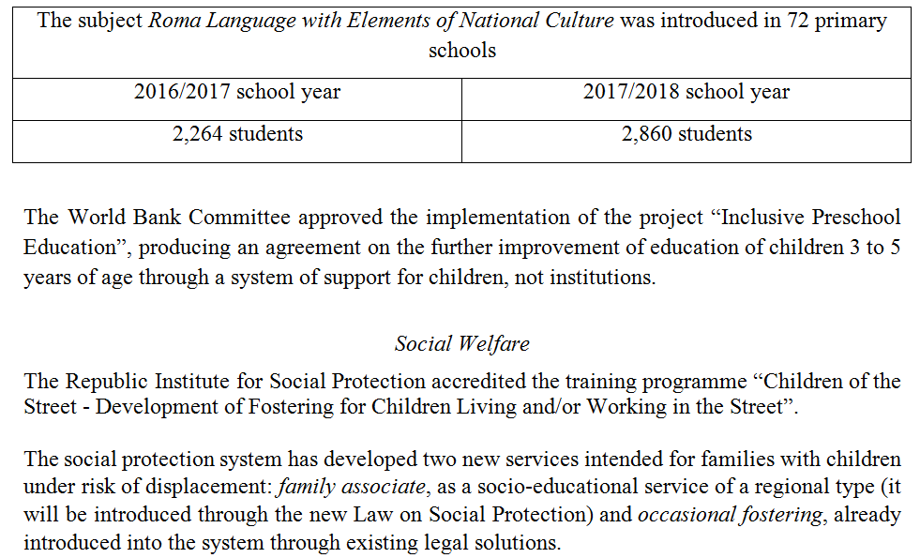
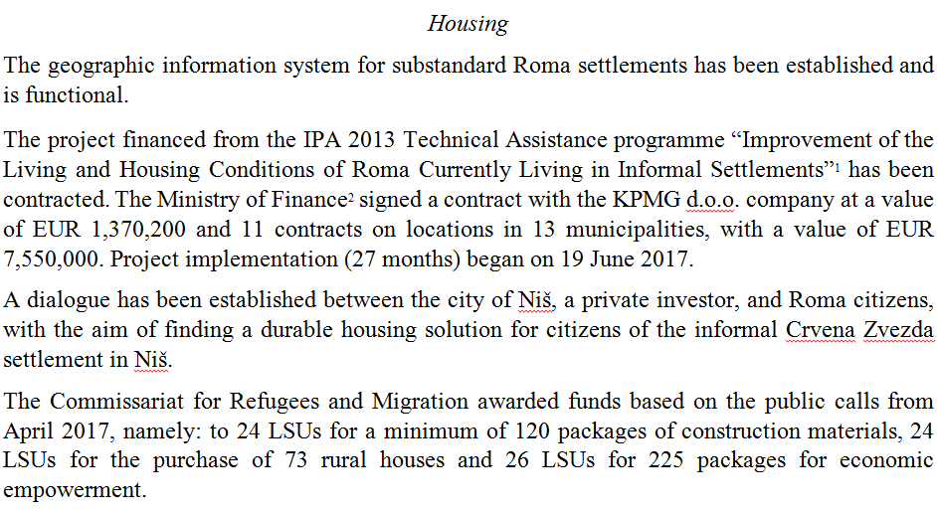

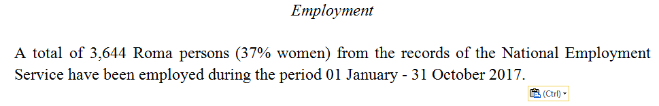

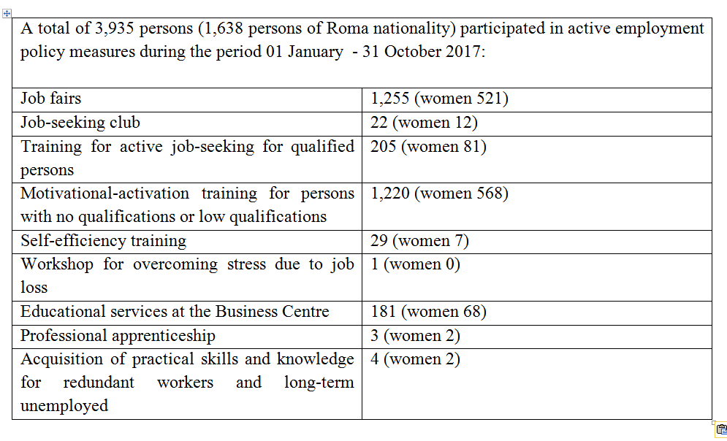
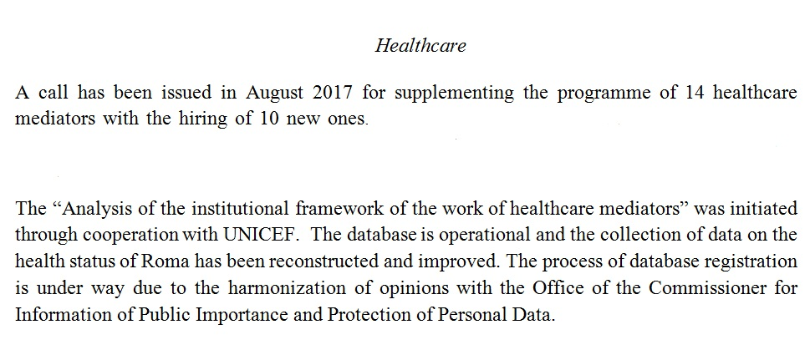

15.(b)
The service “Baby, welcome to the world” from April 2016 simplified the procedure of registering babies in the birth registry, registering citizenship and residence, as well as registering for healthcare insurance electronically, while the baby is still at the birth centre.
The closing conference of the project “European Support for Roma Inclusion” was held in March 2017. The project provided assistance to the institutions of the Republic of Serbia for improving the status of Roma since 2013, through improved access to the labour market, education, healthcare, social protection and housing.
The assessments from the fourth Seminar dedicated to the improvement of the status of Roma, organized by the Government and the European Commission on 19 October 2017, state that compared to other areas of social inclusion of Roma the greatest progress was achieved in ensuring unrestrained exercise of the right to registration in birth registries. The operational conclusions in the areas of Roma inclusion for the period until 2019 are in the final phase of harmonization.
Between 1 September 2016 and 20 December 2017 the MoI has issued decisions establishing residence at the address of the competent Social Work Centres and provided personal documents for 411 persons, the majority living in informal settlements, based on the Rulebook on the application form for registering residence at the address of an institution, and/or social work centre.
Between 1 September 2016 and 20 December 2017, in cooperation with the City Administration of Belgrade and the Secretariat for Social Protection of the City of Belgrade, the MoI registered residences and issued a number of ID cards and passports for residents from part of the “Belvil-Trasa” settlement.
A total of 148 personal ID cards have been issued to Roma citizens between 1 July 2016 and 20 December 2017, through cooperation with the City Administration of Pančevo.
Applying the Law on Citizenship of the RSerbia, the MoI is resolving requests by Roma persons in accordance with the accelerated procedure. By introducing parents into official records their children are being registered as well.
The Office for Kosovo and Metohija is a beneficiary of the project “Promotion and protection of the property rights of IDPs, refugees and returnees based on the Readmission Agreement” (IPA2013), wherein an expert team, in cooperation with the Commissariat for Refugees and Migration and several Roma associations, is preparing and distributing informational material in the Roma language at the Nikola Tesla Airport, providing legal advice and support for the procedure of acquisition of personal documents.

15 (c)
During the 2016/17 school year primary schools have enrolled a total of 711 pupils, returnees based on readmission (369 girls and 342 boys). Due to the flexibility of the system and support measures, these children are being integrated rapidly. Secondary schools have enrolled a total of 15 pupils (6 girls and 9 boys), and the monitoring of these pupils continues throughout the 2017/18 school year.
Support to IDPs and inclusion at the local level continue with the financial support of the European Union through the IPA 2016 programme that, inter alia, envisages the provision of fee-of-charge legal assistance to IDPs in approximately 2,000 court proceedings, as well as increasing the number of mobile teams for social inclusion of Roma from the current 20 to 50 in LSUs. Programmes financed from UNHCR funds and by other donors provided housing for over 3,600 refugee and IDP families (1,416 packages of construction materials, 788 rural houses with yards, 437 prefabricated houses, leasing of 14 residential units with the option of purchase, as well as providing 958 housing units for use intended for social housing under protected conditions). These programmes also provided economic empowerment for 3,252 refugee and IDP families.
The Regulation on establishing an incentive programme for implementing measures and activities required to achieve the goals set in the field of migration management in local self-government units led to the spending of RSD 288 million in 2017, with approximately RSD 300 million envisaged for 2018 for improving the living conditions of IDPs.
Budget funds have been awarded based on public calls from February 2017, namely: to 24 LSUs for a minimum of 105 packages of construction materials and to 25 LSUs for the purchase of 48 rural houses. The Commissariat for Refugees and Migration is issuing public calls several times per year for financing programmes by CSOs and associations of relevance for the population of refugees, IDPs and returnees based on the Readmission Agreement.
When IDPs, including Roma, opt for local integration within the territory of Kosovo and Metohija, not being the place of origin, the Office for Kosovo and Metohija organizes the Programme of construction and reconstruction of housing and relevant public and infrastructural projects (budget funds).
Despite the significant efforts and implemented measures the number of IDPs returned to Kosovo and Metohija is small (lack of security and capability of exercising fundamental human rights or the return of housing facilities and land are unachievable for most).
The number of IDPs from the territory of the AP of Kosovo and Metohija is 201,047, with another 17,000 persons in this province under internal displacement, comprising a total of 218,000 IDPs. Roma, Ashkali and Egyptians represent a particularly vulnerable category. Roma comprise approximately 20,000 (10%) of the population of internally displaced persons. According to the UN Office in Serbia, of the total of 218,000 IDPs, approximately 72,000 IDPS are in a state of need for assistance, among them 23,000 Roma and 49,000 mostly Serbs.

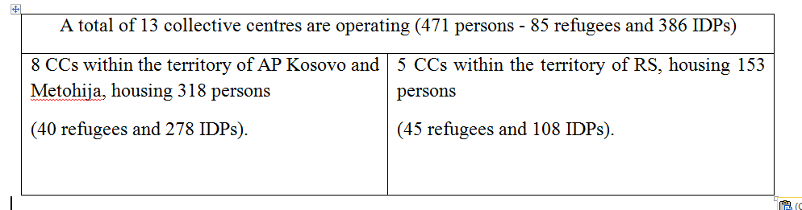
Residents of collective centres are provided with accommodation and food by the Commissariat for Refugees and Migration.
Commissariat data indicates there are 31 so-called unrecognised collective centres, housing around 1,698 beneficiaries, mostly IDPs. Among those, 17 informal/unrecognised CCs are within the territory of Belgrade, housing 1,113 persons. A total of RSD 50 million was spent from the budget between 2014 and 2017 on resolving the housing needs of IDPs accommodated at informal CCs (RSD 30 million for Belgrade and RSD 20 million for Novi Pazar).
Roma, Ashkali and Egyptians represent a particularly vulnerable category. Roma comprise around 20,000 (10%) of the internally displaced population.

15.(d)
The Action Plan for the implementation of the Strategy for the Social Inclusion of Roma for the period 2017-2018 was adopted in June 2017. Of the total amount of funds required to implement this action plan, i.e. RSD 826,865,208 the state is providing 70% or RSD 579,447,264, while donor and other EU funds provide 30%, i.e. RSD 247,417,944 . Regarding the schedule, the state will secure 33.4% in 2017, and 66.6% in 2018.
A total of 48 city/municipal administrations employ persons coordinating, supervising and reporting on the implementation of measures for the social inclusion of Roma, while 26 cities and municipalities have valid local action plans.
A database has been established for monitoring Roma inclusion measures at the local and national level.

Refugees and asylum seekers
33.
A total of 5,965 persons have expressed the desire to seek asylum in the RSerbia between 1 January and 17 September 2017, but only 231 persons have formally commenced the asylum procedure (the procedure has been halted for 156 persons). During the subsequent period refuge was granted for three persons and subsidiary protection status has been awarded for 10 persons.
These persons are not subject to misdemeanour liability and the principle of non-refoulement is respected regarding territories where their life or freedom could be endangered.
Foreign nationals may express the desire to seek asylum at airports, as well as all border crossings, and upon an issued certificate on the expressed intent to seek asylum they are referred to the relevant asylum centre. All officials of the Asylum Office have completed the relevant training.
The principle of “safe third country” is applied based on the List of Safe Third Countries, established by the Government, upon proposal by the MFA, taking into account the circumstances of the specific case.
The plan of reacting to the increased number of migrants within the territory of the RSerbia was revised for the period April-December 2017, while the one for January-December 2018 is in the adoption procedure.
The total capacities of the 18 reception and permanent centres are 6,000 persons, with the option of increase through the use of facilities intended for shorter stays (an additional 10%).
Accommodation capacities are being further improved to be compliant with EASO standards. The Commissariat will introduce EASO tools for the identification of persons with development impairments, and will develop the implementation monitoring system with the support of the European Commission.
All centres are located within or near settlements. Certain services are also provided within the centres (each one has a space for providing healthcare protection), and transport is provided to local service providers when necessary.
Accommodation in centres is provided without any form of discrimination. Premises for the accommodation of single persons are gender-segregated. Families with children are accommodated together. Unaccompanied minors are placed in separate premises (if remaining in the centre is in the best interests of the child). All centres have premises specifically adapted for children.
All facilities provide a minimum of 4.5m2 per accommodated person in case of the optimum number of persons. Under maximum usage conditions the surface area per accommodated person is below the minimum at only two centres. Wireless internet access is provided along with conditions for charging private electronic devices.
Food covers three meals per day, in accordance with nutritional standards and religious affiliation. Sufficient adequate clothing and footwear, as well as personal hygiene items have been provided.
The standards regarding the number of persons per single shower/toilet have been fully achieved in all bar one centre, with 24 hour access to unlimited amounts of potable water. Hygiene is maintained by employees, and DDD is also regularly implemented.
Regular heating has been provided with sufficient fuel, provided from both budget and donor funds.
Space has also been provided for CSOs providing free-of-charge legal assistance or psychosocial support. Full and timely information is provided to migrants and contact with authorized UNHCR officials. Information is available on options for voluntary return through cooperation with IOM.
The preliminary observations by the UN Special Rapporteur on the prevention of torture and other cruel, inhuman or degrading treatment or punishment from November 2017 indicate there are no violations of human rights regarding living conditions at the accommodation facilities serving for the reception and accommodation of migrants and asylum-seekers.
The working group for providing support in the education of student refugees and asylum-seekers in institutions of the education system improved coordination and activities with institutions and achieved a high level of cooperation with international organizations (UNICEF, OSCE, Save the Children) and CSOs (Danish Refugee Council, Group 484, Indigo, SOS village, Novak Đoković Foundation).
The laws in force provide for systematic inclusion of student migrants and asylum-seekers into the educational system. The Professional instructions for the inclusion of refugee/asylum-seeker children into the education system established procedures for the inclusion, support and monitoring of students.
A total of 101 students have been included into the educational system during the 2016/17 school year, in 6 primary schools. A total of 95% of primary school aged children accommodated in refugee centres have been covered during the 2017/18 school year, across 45 primary schools (nine school administrations, 503 students, with educational support provided in transit centres for 83 children). The line ministry organized mentor support for schools; trainings for 500 employees from 17 municipalities near 18 collective centres; they divided and distributed 2,188 school packages, provided by UNICEF, and implement permanent monitoring of the process of inclusion and support to staff and students.

Freedom of expression
39.(a)
A TAIEX mission was organized upon request by the Ministry of Justice during the period 16-17 March 2017, with the aim of implementing an analysis of the relevant provisions of the Criminal Code to better protect journalists. The experts held a number of meetings with state institutions as well as representatives of journalist associations (UNS, NUNS) and CSOs.
The Agreement on cooperation and measures to increase the level of security of journalists was signed on 26 December 2016 by MoI, RPP, Association of Serbian Journalists, Independent Association of Serbian Journalists, Association of Journalists of Vojvodina, Association of Independent Electronic Media, Association of Media and Association of Online Media. The Independent Society of Journalists of Vojvodina acceded to the same on 18 January 2017. The working group implementing this agreement held meetings continuously throughout 2017, and the representatives of the OSCE Mission to Serbia expressed their readiness to provide support in implementing the agreement.
A mechanism of cooperation was established between the signatory parties in cases of criminal offences against journalists and members of the subgroup for the analysis of the provisions of the Criminal Code and actions by competent bodies have been appointed, as well as the subgroup for the analysis of the method of communication and degree of openness of competent institutions towards media to date.
A comparison was also produced of the data contained in public prosecution records on criminal charges and criminal proceedings regarding crimes committed against journalists with the data held by NUNS.
A result of the work of the standing working group was the drafting of a newsletter - Notice on the actions of public prosecution regarding crimes committed against journalists in 2016 and 2017.
The Republic Public Prosecutor’s Office appointed secondary and tertiary contact points for each appeals public prosecutor’s office with the aim of increasing the efficiency of cooperation.
The OSCE Mission to Serbia organized consultations on 18 December 2017 on journalist safety - international and local standards and procedures.
The standing working group held a meeting in January 2018 with representatives of the European Federation of Journalists, the International Journalism Institute and the Media Organization of South-East Europe, to analyse the implementation of the agreement. In a separate meeting with representatives of the Republic Public Prosecutor’s Office and the Ministry of Justice, these organizations analysed the results of public prosecutors in criminal proceedings, as well as the legislative framework in force regarding journalist protection.

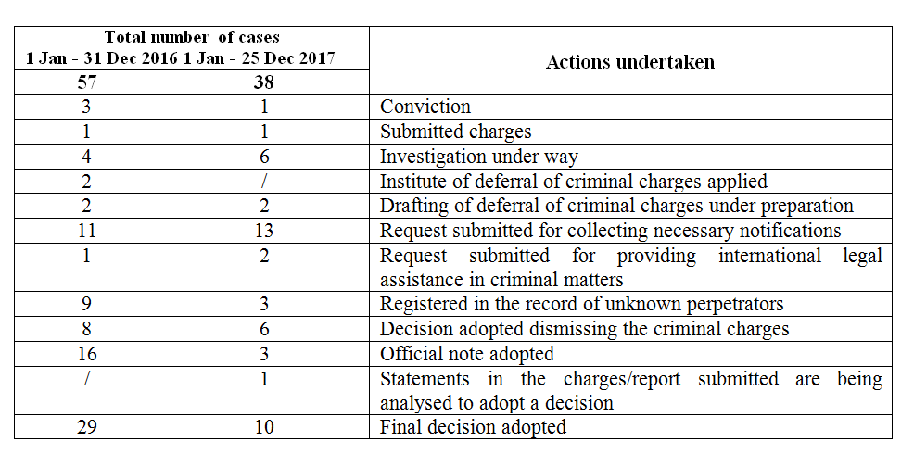
The Ministry of Culture and Information supported a project by the Independent Association of Serbian Journalists in cooperation with OSCE in 2016 and 2017, entitled Freedom of Media and Safety of Journalists in Serbia.

39. (b)
The public prosecution is an independent state body prosecuting the perpetrators of criminal and other punishable acts and the public prosecutor has the obligation to undertake criminal prosecution when there is a basis for suspicion that a criminal offence has been committed or that a certain person has committed a criminal offence prosecuted under official duties.
Any person committing a criminal or other punishable offence shall be processed and punished by law, including journalists, human rights defenders and other members of civil society if they commit a criminal or other punishable act prescribed by law, and not in relation to their professional activities.
According to available data in the Republic of Serbia there are no cases where a public prosecutor has undertaken criminal prosecution against a journalist regarding the work they are doing (or in regards to the practice of the profession of journalist).
39.(c)
The media laws from 2014 are fully harmonized with European and international standards. These laws protect the independence of media and provide for transparency in the ownership structure of media.
The Law on Public Information and Media introduced the Media Register, containing data on legal and natural persons directly or indirectly having over 5% share of the founding capital, thus contributing to the prevention of media monopoly in accordance with Article 40 of General Observation no. 34 on the freedom of opinion and expression. The Media Register is being regularly updated and is accessible to all stakeholders on the website of the Business Registrar’s Agency.
The Law on Public Information and Media regulates the right to freedom of public information as follows: that public information is free and not subject to censorship; the direct and indirect discrimination of media editors and journalist according to their political affiliation and beliefs or other personal characteristics is prohibited; the free flow of information cannot be jeopardised, nor the editorial autonomy of media, particularly by exerting pressure, threats, and/or blackmail of editors, journalists or sources of information; the freedom of public information may not be violated through the abuse of office and public authorization, property and other rights, or influence and control over means of printing and distribution of newspapers or electronic communications networks used to distribute media content.
Bodies competent for public information in the RSerbia, autonomous province, and/or LSU shall secure funds from the budget for the realization of public interest in the area of public information and distribute the same based on implemented public calls and through individual handouts, based on the principle of awarding state aid and protection of competition, without discrimination. A professional committee comprised of independent media experts or media workers evaluates projects and adopts a decision on the distribution of funds, submitted to the Media Register. This provides insight and control over awarded low-value state funds. Upon the expiry of project co-financing during the current year, an analysis is drafted of the quality of supported projects based on the reports of beneficiaries, published on the website of the relevant body.
The Ministry of Culture and Information implemented a survey in 2017 among LSUs with the aim of monitoring the implementation of the Law on Public Information and Media, producing an analysis of the effects of the implementation of the law, as well as an assessment of the needs and capacities of local self-governments to implement the law. The Ministry will analyse the key issues and organize trainings to remedy any deficiencies noted.

39.( d)
The Law on Public Assembly introduced novelties to provide greater rights to organizers of public gatherings (extended deadline for registering public assemblies - 5 days prior to the start of the event) and in exempting event organizers from reporting gatherings held in closed spaces, religious and other traditional events, as well as instances of spontaneous assembly.

RMUSP (Romа Memorial University Scholarship Program) and RHP (Roma Health Program)
social welfare and healthcare, employment, housing
EuropeAid/131328/C/SER/RS
Regarding durable solutions (as envisaged by the Framework for Durable Solutions for IDPs) both return and reintegration should be given a chance.
http://www.inkluzijaroma.stat.gov.rs/sr
Ministry of Justice, RPP, MoI, Ministry of Culture, European Integration Office
regarding the analysis of the criminal-legal protection of journalists and securing the data required to increase the level of protection and identifying the risk of vulnerability of journalists and other media stakeholders; education of journalists and media owners, as well as training for representatives of the prosecution and the police, as well as providing expert assistance.

